**BONUS Assignment for EVERYONE (especially for learning purpose)**[Instructor of the course: Dr. Mahdy Rahman; Session: spring 2020]

Before Einstein’s invention of the special theory of relativity, everyone considered Maxwell’s equations of electromagnetism as the fundamental postulates without much explanation. For example- no one knew in detail: why the moving electric charges (i.e. current) always create circulating closed line magnetic fields and so on [the deeper physics behind Ampere’s law]. It was Einstein’s genius which figured out: what is the deeper physics behind such matters. A clerk (not even an officer) of a patent office (Einstein) published a journal on special theory of relativity in 1905 [just after submitting his PhD thesis] where he explained such things fully theoretically without any real experiment (half of his paper was full of those explanations). Now, try to explain **in detail** taking the help of internet/ books [I will be very happy to judge the way (s) of your explanation (s); which should not be a ‘copy-paste’ type thing. Also: do not discuss with others. Happy learning!!!!]:

**Question: Why the electric field (with no magnetic field at all) in one frame of reference can be observed as an altered electric field and magnetic field (!!!!) in another frame of reference [figure is given below].**

* This means: the ‘reality’ [whatever it actually is!!!], observed in one frame of reference, may be found ‘different’ from another frame of reference.

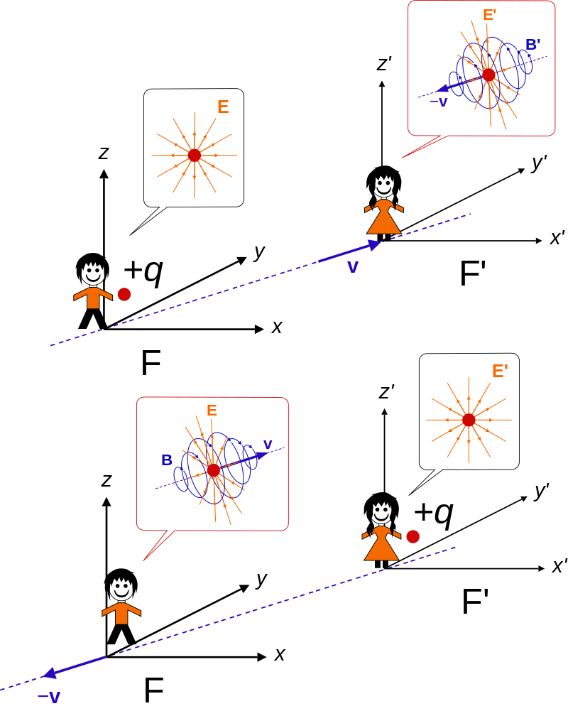[Einstein got ‘promotion’ in 1906 (in his patent office) after publishing his four ground breaking papers in 1905 (just after his PhD), which almost destroyed the Newtonian philosophy of physics. However, Einstein was promoted to a 2nd class technical expert (nothing much significant) from his previous rank of clerk in his patent office due to those ground breaking works. Even after those publications, he failed to manage any faculty position in academia in 1906, 1907 and 1908. In fact the world was not ready enough to accept his extraordinary works at that time. Some people severely criticized his works. Einstein got his first faculty position in 1909 (long time after the submission of his PhD thesis) and the rest is history. He did not publish thousands of scientific articles. He published few ground breaking notable works and those works have made him immortal.]

Figure (collected): “Lorentz boost of an electric charge. **Top:** The charge is at rest in frame F, so this observer sees a static electric field. An observer in another frame F′ moves with velocity **v** relative to F, and sees the charge move with velocity −**v** with an altered electric field **E**  and a magnetic field **B** . **Bottom:** Similar setup, with the charge at rest in frame F′.”